**Appendix 1: Planning Guide**

Task 0 : Explain what you are doing/ going to accomplish

In this version I will be creating a basic python server for my website.

Task 1: Sketch interface design

*Draft a rough design for the interface that allows the user to trigger functionality in task 1, while also annotating where the information in task 2 will be displayed. Create another sketch listing the interface widgets used to create the interface.*

N/A

Task 2: Identify any classes required

*Explain what the class will represent, plus listing what information will be stored in the class and any functions the class will have.*

Class to hold the items in our canteen

Task 3: Identify information to be displayed

*What information will the interface need to display to the user?*

N/A

Task 4: Identify user inputs

*What program functions can the user trigger through the interface?*

N/A

Task 5: Identify any constants or existing data if required

*Canteen items will be constants*

Task 6: Identify indexed data structures

*The test data will be:*

*Pies – 10 in stock*

*Pasta Salad – 8 in stock*

*Toasted sandwich – 9 in stock*

Task 7: Determine what calculations are necessary

*Write out the calculations the program will have to compute.*

Task 8: Develop a modular structure for your program

*Describe any functions that the computer program will have, identifying any sub-functions where required.*

Program __init__

Task 9: Define the functions identified

*Describe the functions for both the main program and any classes in terms of input and/or output where required. You may choose to do this with flow charts or pseudo-code (not Python code!). Add in additional steps or explanations using sequential, conditional, iterative statements where required. Identify global and/or local variables.*

|  |
| --- |
| IMPORT run, route, view, get, post, FROM bottle |
|  | IMPORT count FROM itertools |
|  |  |
|  | CLASS Canteen: |
|  | PROGRAM __init__: pass self, food_name, food_stock |
|  | SET self.id to next self._ids |
|  | SET self.name to food_name |
|  | SET self.amount to food_stock |
|  | END |
|  |  |
|  | SET LIST to Food |
|  | Canteen is set to Super Dude, 8 |
|  | Canteen is set to Lizard Man, 12 |
|  | Canteen is set to Water Woman, 3 |
|  |  |
|  |  |
|  | run(host='0.0.0.0', port = 8080, reloader=True, debug=True) |

Task 10: Address any relevant implications such as usability, functionality, legal/ethical requirements.

Task 11: Document test cases for testing the program

*Document any testing that can be used to test your program. If any input is inputted using the keyboard, describe the expected input, plus any exceptional, boundary or invalid cases.*

When I asked the program to run, it ran

Task 12: Refine the plan

*Note any modifications here when iterating through the development cycles.*

No modifications were needed

Task 13: Document testing

*Show screenshots of your program working with descriptions of each image. These images should test the tests cases listed above.*

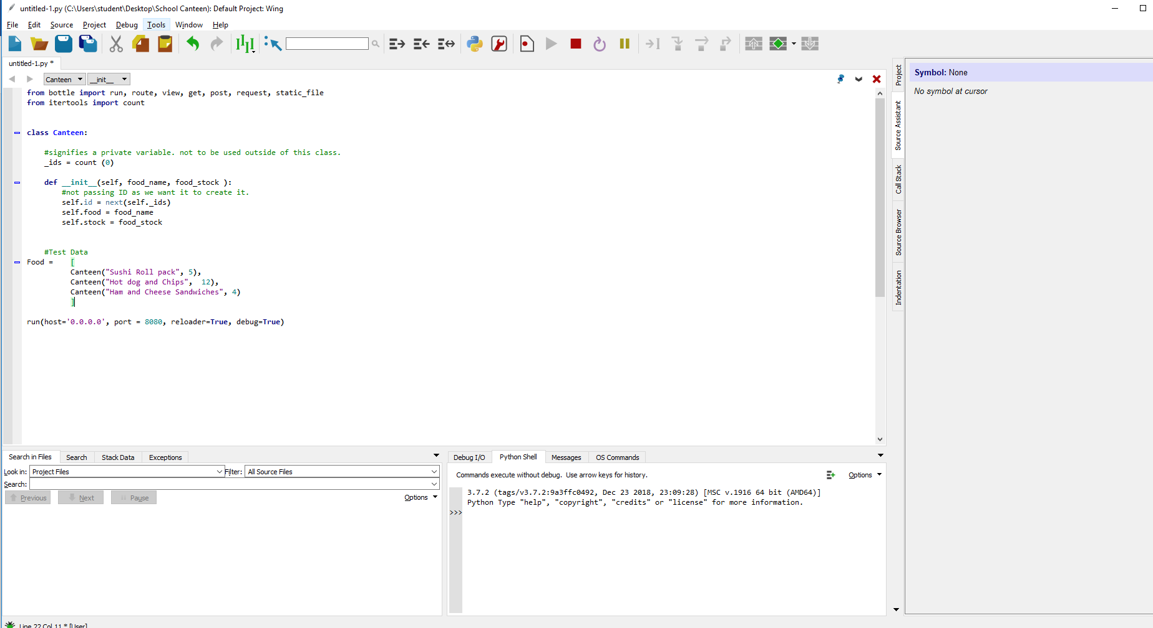

Task 14: Evaluation

*How did your version turn out?*

First version worked properlly